|  |
| --- |
| **EXP-01 Comprehensive report on the fundamentals of generative**  **DATE AI and large language models** |

Jijendra Prasaath S B - 212221030015

**Aim:** To develop a report that explains the foundational concept of generative AI focusing on architecture like transformers their applications and impact of scaling in LLM

**Procedure:**

Generative AI refers to a class of artificial intelligence techniques that can generate new content, including text, images, audio, and more, based on learned patterns from existing data. Large language models (LLMs) are a prominent subset of generative AI, particularly focused on natural language processing (NLP). This report will explore the foundational concepts of generative AI, the architecture of LLMs, their applications, and the impact of scaling these models.

1. **Fundamentals of Generative AI**

**1.1 Definition**

Generative AI involves algorithms that can create new data instances that resemble a training dataset. Unlike discriminative models that classify data points, generative models learn the underlying distribution of the data, enabling them to produce novel outputs**.**

**1.2 Types of Generative Models**

* **Generative Adversarial Networks (GANs):** Composed of a generator and a discriminator, GANs work through adversarial training where the generator creates data and the discriminator evaluates its authenticity.
* **Variational Autoencoders (VAEs):** These models encode input data into a latent space and then decode it back, allowing for the generation of new samples from the learned distribution.
* **Autoregressive Models:** These predict the next element in a sequence based on prior elements, widely used in text generation.

1. **Architecture of Large Language Models**

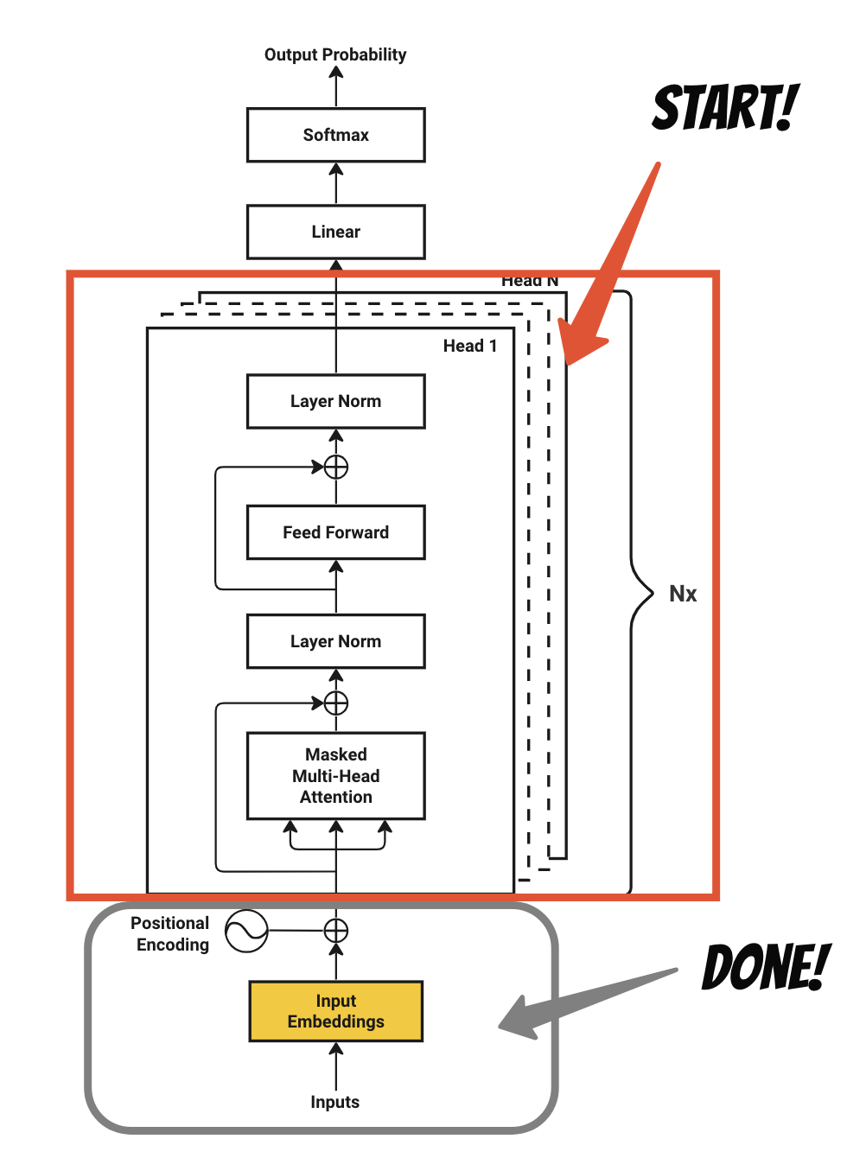

**2.1 Transformer Architecture**

The transformer model, introduced in the paper "Attention is All You Need" by Vaswani et al. (2017), is the backbone of many LLMs. Key components include:

* **Self-Attention Mechanism:** This allows the model to weigh the importance of different words in a sentence relative to each other, capturing contextual relationships effectively.
* **Positional Encoding**: Since transformers do not have a built-in notion of sequence, positional encodings are added to give the model information about the order of words.
* **Multi-Head Attention**: This enables the model to focus on different parts of the input simultaneously, enhancing its ability to capture various linguistic features.
* **Feed-Forward Neural Networks**: After attention layers, the data is processed through feed-forward networks to further refine representations.
* **Layer Normalization and Residual Connections:** These techniques improve training stability and efficiency**.**

**2.2 Training Techniques**

* **Pre-training and Fine-tuning**: LLMs are typically pre-trained on large datasets using unsupervised learning and then fine-tuned on specific tasks using supervised learning.
* **Transfer Learning**: Pre-trained models can be adapted for various NLP tasks with relatively small datasets, improving performance and reducing the need for extensive labeled data.

**3. Applications of LLMs**

**3.1 Natural Language Processing**

* **Text Generation**: LLMs can create coherent and contextually relevant text for applications such as story generation, chatbots, and content creation.
* **Translation:** Models like OpenAI's GPT and Google's BERT can translate languages with high accuracy, improving communication across linguistic barriers.
* **Summarization**: LLMs can condense long texts into concise summaries, aiding in information retrieval and comprehension.

**3.2 Creative Arts**

* **Music and Art Generation**: Generative models extend beyond text to create music and visual art, offering new avenues for creative expression.
* **Game Development**: AI can generate narratives, characters, and environments in video games, enhancing user experiences.

**3.3 Business and Industry**

* **Customer Support**: LLMs can power chatbots and virtual assistants, providing real-time support and information.
* **Market Analysis**: Text analysis can identify trends and sentiments from large volumes of data, aiding decision-making.

**4. Impact of Scaling in LLMs**

**4.1 Improvements in Performance**

Scaling LLMs, in terms of both data and model size, has led to significant performance improvements. Larger models can capture more nuanced patterns and relationships within data, resulting in:

* **Enhanced Coherence**: Bigger models generate more coherent and contextually appropriate text.
* **Broader Knowledge**: Larger training datasets enable models to learn from diverse sources, improving their knowledge base.

**4.2 Ethical and Societal Considerations**

* **Bias and Fairness**: Larger models can inadvertently amplify biases present in training data, raising ethical concerns about their deployment.
* **Resource Consumption**: Scaling LLMs requires substantial computational resources, raising questions about environmental impact and accessibility.

**4.3 Future Directions**

* **Sustainable AI**: Research is ongoing to make LLM training more efficient and environmentally friendly.
* **Interdisciplinary Applications**: As LLMs continue to evolve, their applications may expand into areas like healthcare, law, and education, offering transformative potential.

**Conclusion**

Generative AI and large language models represent a significant leap in artificial intelligence, with their transformer architecture enabling unprecedented capabilities in text generation and understanding. As these models continue to scale, their applications will expand, but ethical considerations and responsible use will be critical to harnessing their potential for societal benefit. Ongoing research and innovation will shape the future landscape of generative AI, ensuring it remains a powerful tool for creativity and communication.